**Concepts of Operating System**

**Assignment 1**

**Problem 1: Read the instructions carefully and answer accordingly. If there is any need to insert some data then do that as well.**

**a) Navigate and List:**

a. Start by navigating to your home directory and list its contents. Then, move into a

directory named "LinuxAssignment" if it exists; otherwise, create it.

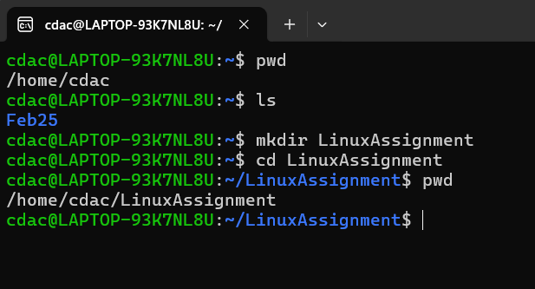

Step 1 : Navigate to home directory – cd ~

Step 2: List the content of home directory - ls

Step 3: Create the “LinuxAssignment” directory ( if it doesn’t exists) – mkdir LinuxAssignment

Step 4 : Move into the “LinuxAssignment” directory – cd LinuxAssignment

Step 5 : Confirm you are inside the “LinuxAssignment” directory - pwd

**b) File Management:**

a. Inside the "LinuxAssignment" directory, create a new file named "file1.txt". Display its

contents.

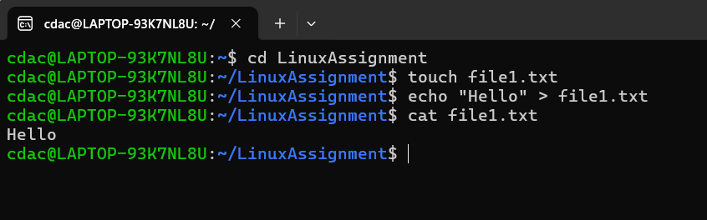

Step 1: Move into the “LinuxAssignment” – cd LinuxAssignment

Step 2 : Create a New File named “File1.txt” – touch file1.txt

Step 3 : use ‘echo’ to create a file with some content : echo “Hello” > file1.txt

Step 4: display the contents of “file1.txt” – cat file1.txt

**c) Directory Management:**

a. Create a new directory named "docs" inside the "LinuxAssignment" directory.

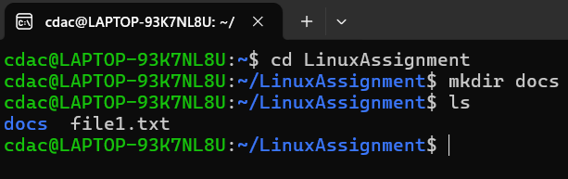

Step 1: Move into the “LinuxAssignment” – cd LinuxAssignment

Step 2 : Create a New directory named “docs” – mkdir docs

Step 3 : Verify that the directory was created : ls

**d) Copy and Move Files:**

a. Copy the "file1.txt" file into the "docs" directory and rename it to "file2.txt".

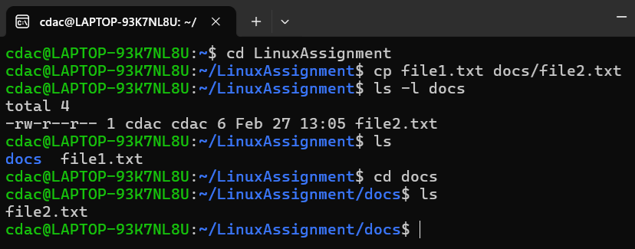

Step 1: Move into the “LinuxAssignment” – cd LinuxAssignment

Step 2 : copy “file1.txt” to “docs” directory and rename it to “file2.txt” – cp file1.txt docs/file2.txt

Step 3 : Verify the copy operation – ls -l docs

**e) Permissions and Ownership:**

a. Change the permissions of "file2.txt" to allow read, write, and execute permissions for

the owner and only read permissions for others. Then, change the owner of "file2.txt" to

the current user.

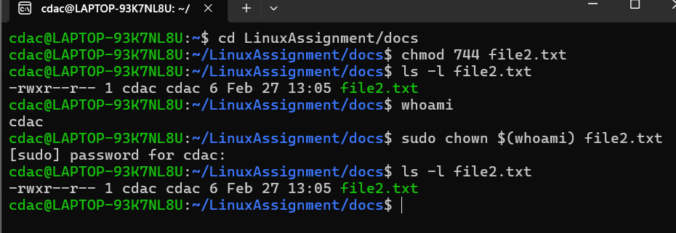

Step 1: Move into the “docs” – cd LinuxAssignment/docs

Step 2 : Change File Permissions of “file2.txt” – chmod 744 file2.txt

// 7 (Owner) → Read (r), Write (w), Execute (x)

//4 (Group) → Read only (r--)

//4 (Others) → Read only (r--)

Step 3: verify the permissions – ls -l file2.txt

Step 4 : Change the Owner of “file2.txt” to the Current user

*confirm current username – whoami

*change the file owner – sudo chown $(whoami) file2.txt

Step 5 : Verify the owner - ls -l file2.txt

**f) Final Checklist:**

a. Finally, list the contents of the "LinuxAssignment" directory and the root directory to

ensure that all operations were performed correctly.

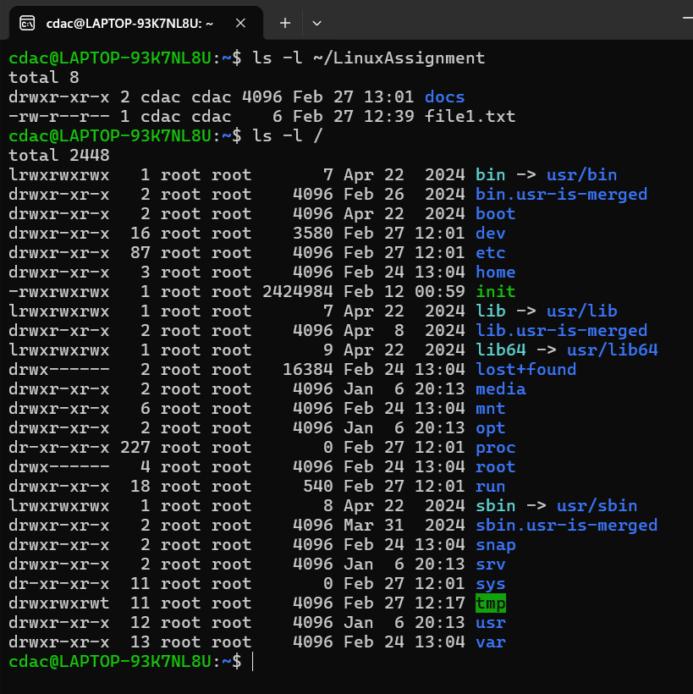

Step 1: List Content of “LinuxAssignment” directory - ls -l ~/LinuxAssignment

Step 2: List the contents of the Root directory – ls -l /

**g) File Searching:**

a. Search for all files with the extension ".txt" in the current directory and its subdirectories.

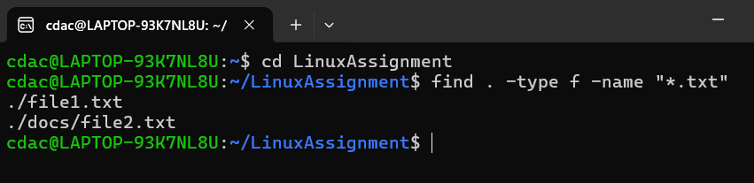

**Find . -type f -name “*.txt”**

// find : search for files and directories

// . : start searching from the current directory

// -type f : look for files (not directories)

// -name “.txt” : match files ending in .txt

b. Display lines containing a specific word in a file (provide a file name and the specific

word to search).

**grep “Hello” file1.txt**

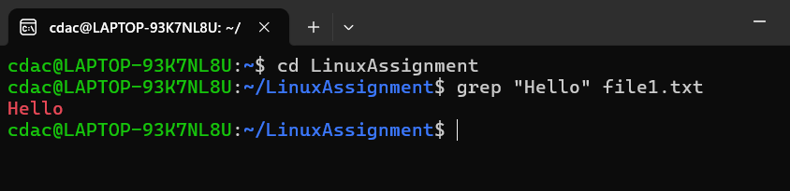

**h) System Information:**

a. Display the current system date and time.

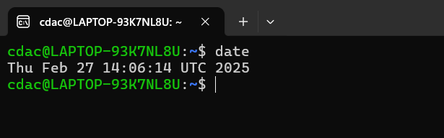

**Answer :** date

**i) Networking:**

a. Display the IP address of the system.

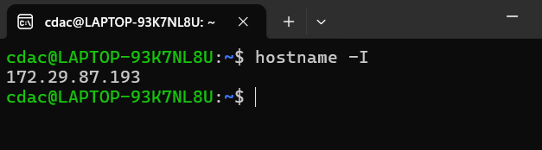

**Command** : hostname -I

b. Ping a remote server to check connectivity (provide a remote server address to ping).

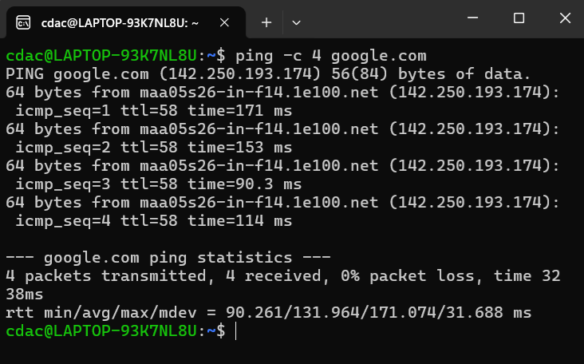

**Command :** ping -c 4 google.com

**j) File Compression:**

a. Compress the "docs" directory into a zip file.

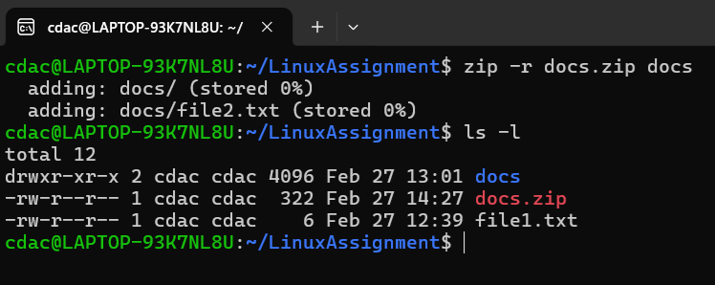

**Command** : zip -r docs.zip docs

Ls -l

b. Extract the contents of the zip file into a new directory.

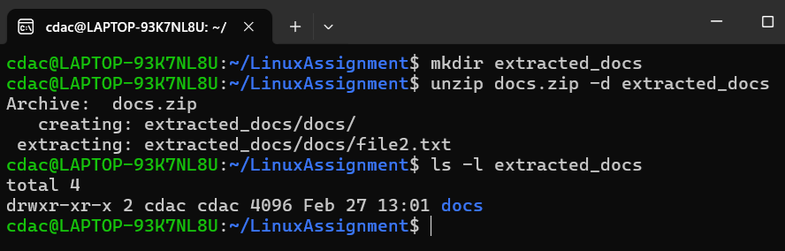

Step 1 : create a new directory for Extraction : mkdir extracted_docs

Step 2: Extract docs.zip into extracted_docs : unzip docs.zip -d extracted_docs

Step 3 : Verify extraction : ls -l extracted_docs

**k) File Editing:**

a. Open the "file1.txt" file in a text editor and add some text to it.

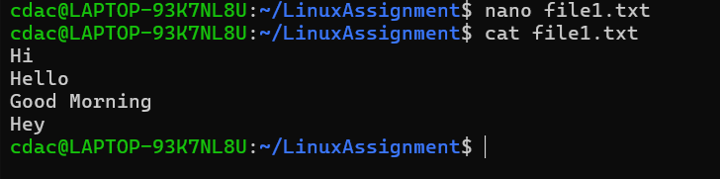

Nano file1.txt

b. Replace a specific word in the "file1.txt" file with another word (provide the original

word and the word to replace it with).

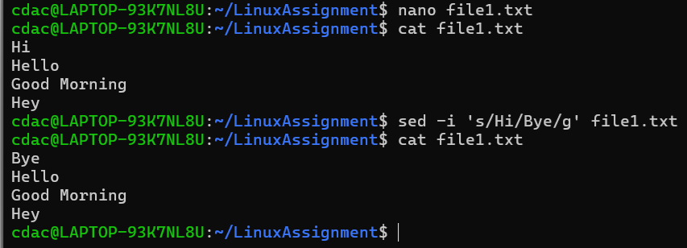

Sed -I ‘s/Hi/Bye/g’ file1.txt

**Problem 2: Read the instructions carefully and answer accordingly. If there is**

**any need to insert some data then do that as well.**

a. Suppose you have a file named "data.txt" containing important information. Display the

first 10 lines of this file to quickly glance at its contents using a command.

**Answer:**

head -n 10 data.txt

head Command is used to display the beginning of a file.

-n 10: Specifies that the first 10 lines should be displayed.

b. Now, to check the end of the file for any recent additions, display the last 5 lines of

"data.txt" using another command.

**Answer:**

tail -n 5 data.txt

tail Command is used to display the end of a file.

-n 5: Specifies that the last 5 lines should be displayed

c. In a file named "numbers.txt," there are a series of numbers. Display the first 15 lines of

this file to analyze the initial data set.

Answer:

head -n 15 numbers.txt

head: Displays the beginning of a file.

-n 15: Specifies that the first 15 lines should be shown.

numbers.txt: The file containing the series of numbers.

d. To focus on the last few numbers of the dataset, display the last 3 lines of "numbers.txt".

Answer:

tail -n 3 numbers.txt

tail: Displays the end of a file.

-n 3: Specifies that the last 3 lines should be shown.

e. Imagine you have a file named "input.txt" with text content. Use a command to translate

all lowercase letters to uppercase in "input.txt" and save the modified text in a new file

named "output.txt."

**Answer:**

cat input.txt | tr 'a-z' 'A-Z' > output.txt

cat input.txt: Reads the content of input.txt.

tr 'a-z' 'A-Z': Translates all lowercase letters to uppercase.

> output.txt: Redirects the modified content to a new file named output.txt.

f. In a file named "duplicate.txt," there are several lines of text, some of which are

duplicates. Use a command to display only the unique lines from "duplicate.txt."

g. In a file named "fruit.txt," there is a list of fruits, but some fruits are repeated. Use a

command to display each unique fruit along with the count of its occurrences in

"fruit.txt."

Submission Guidelines:

• Document each step of your solution and any challenges faced.

• Upload it on your GitHub repository

Additional Tips:

• Experiment with different options and parameters of each command to explore their

functionalities.